In Product details after clicking the **Add to Cart**

1. 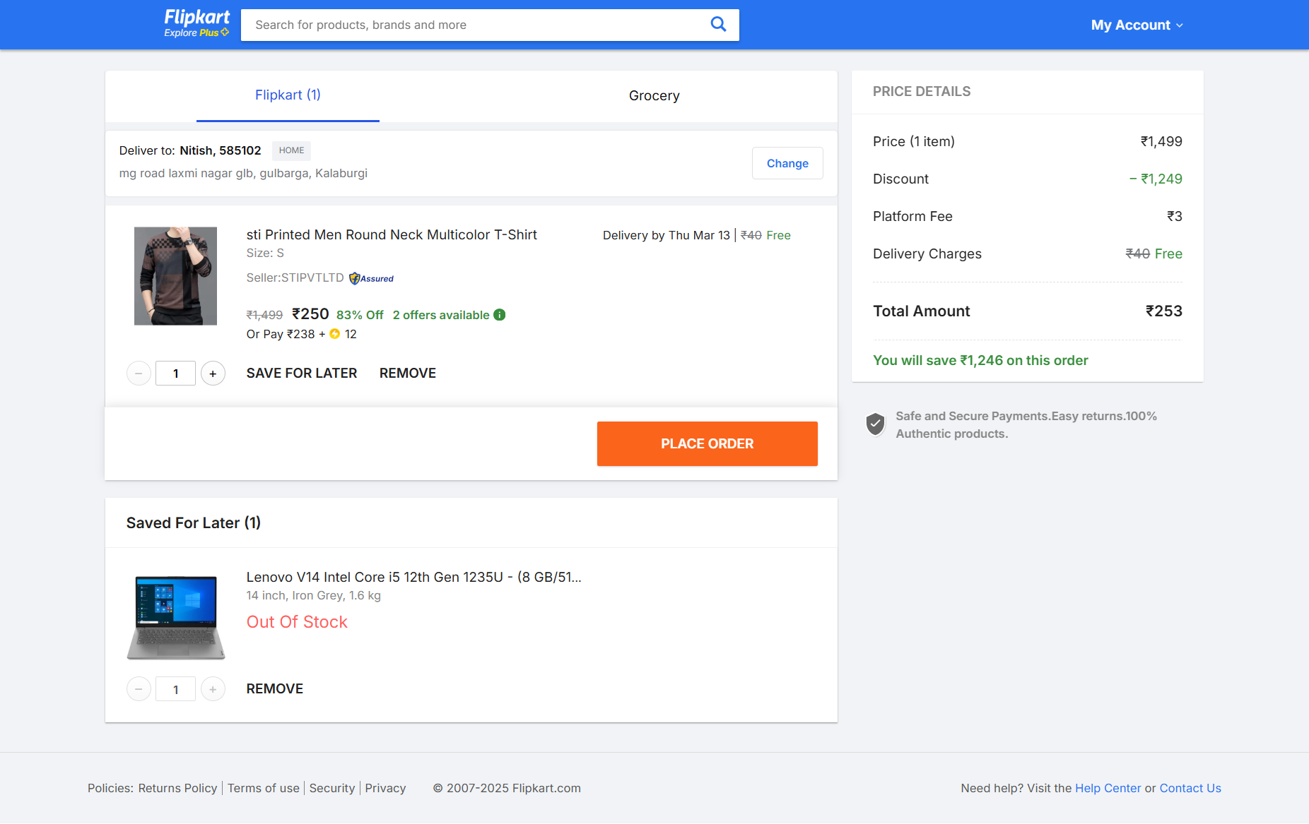

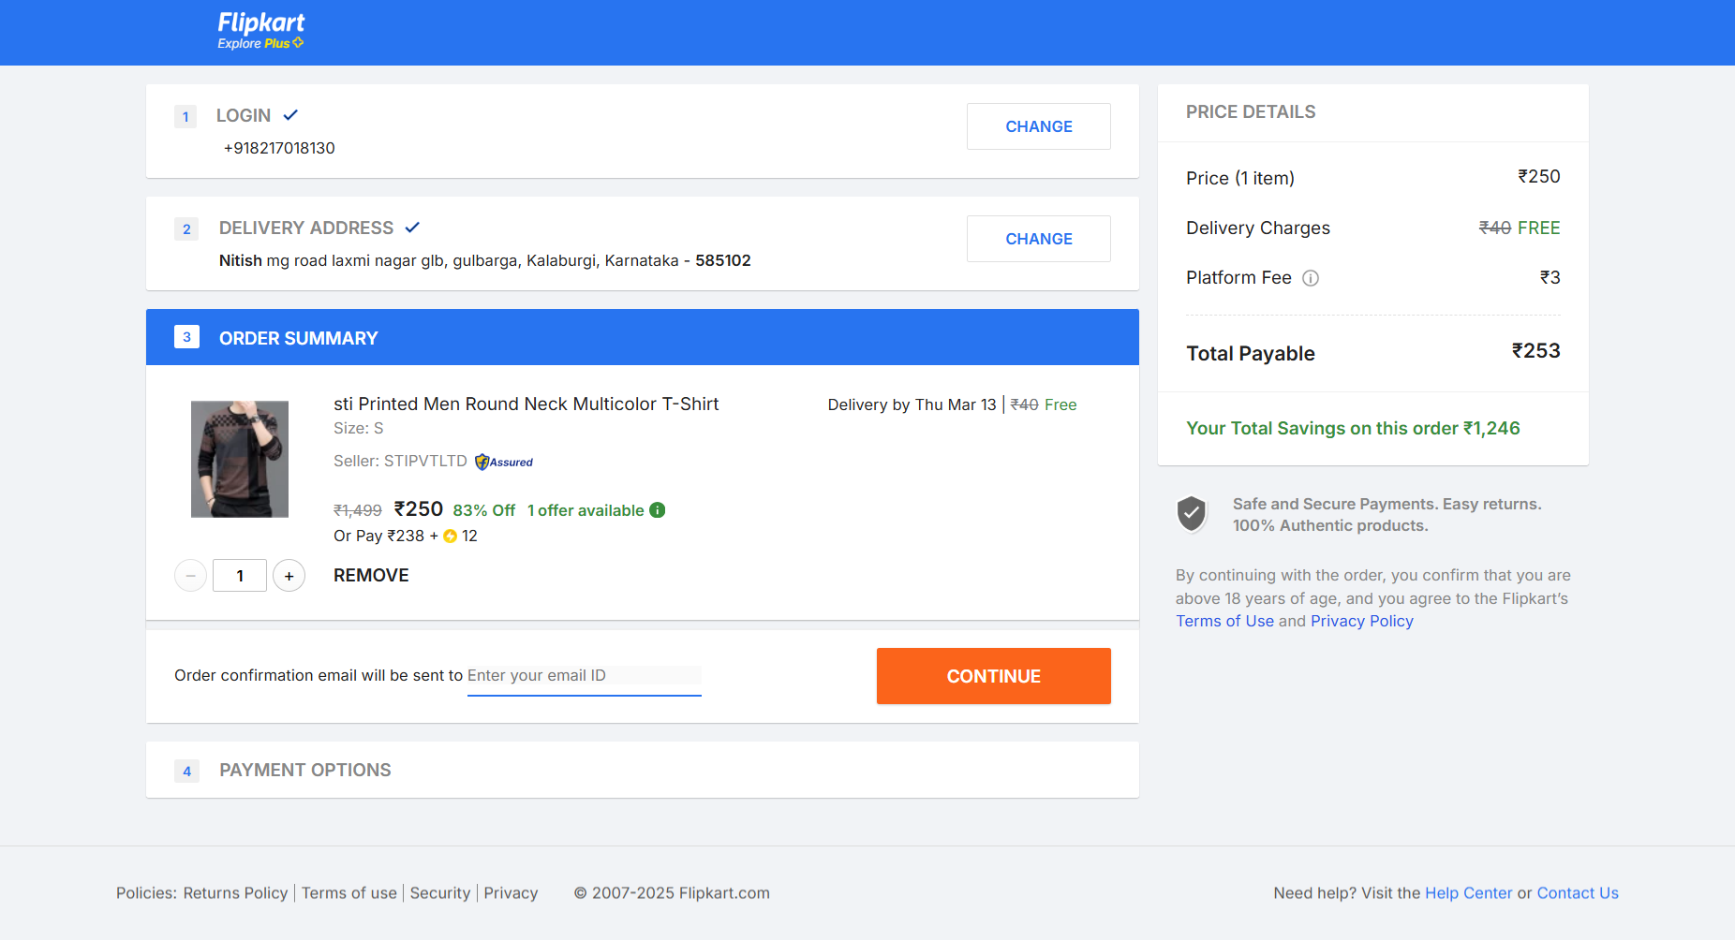



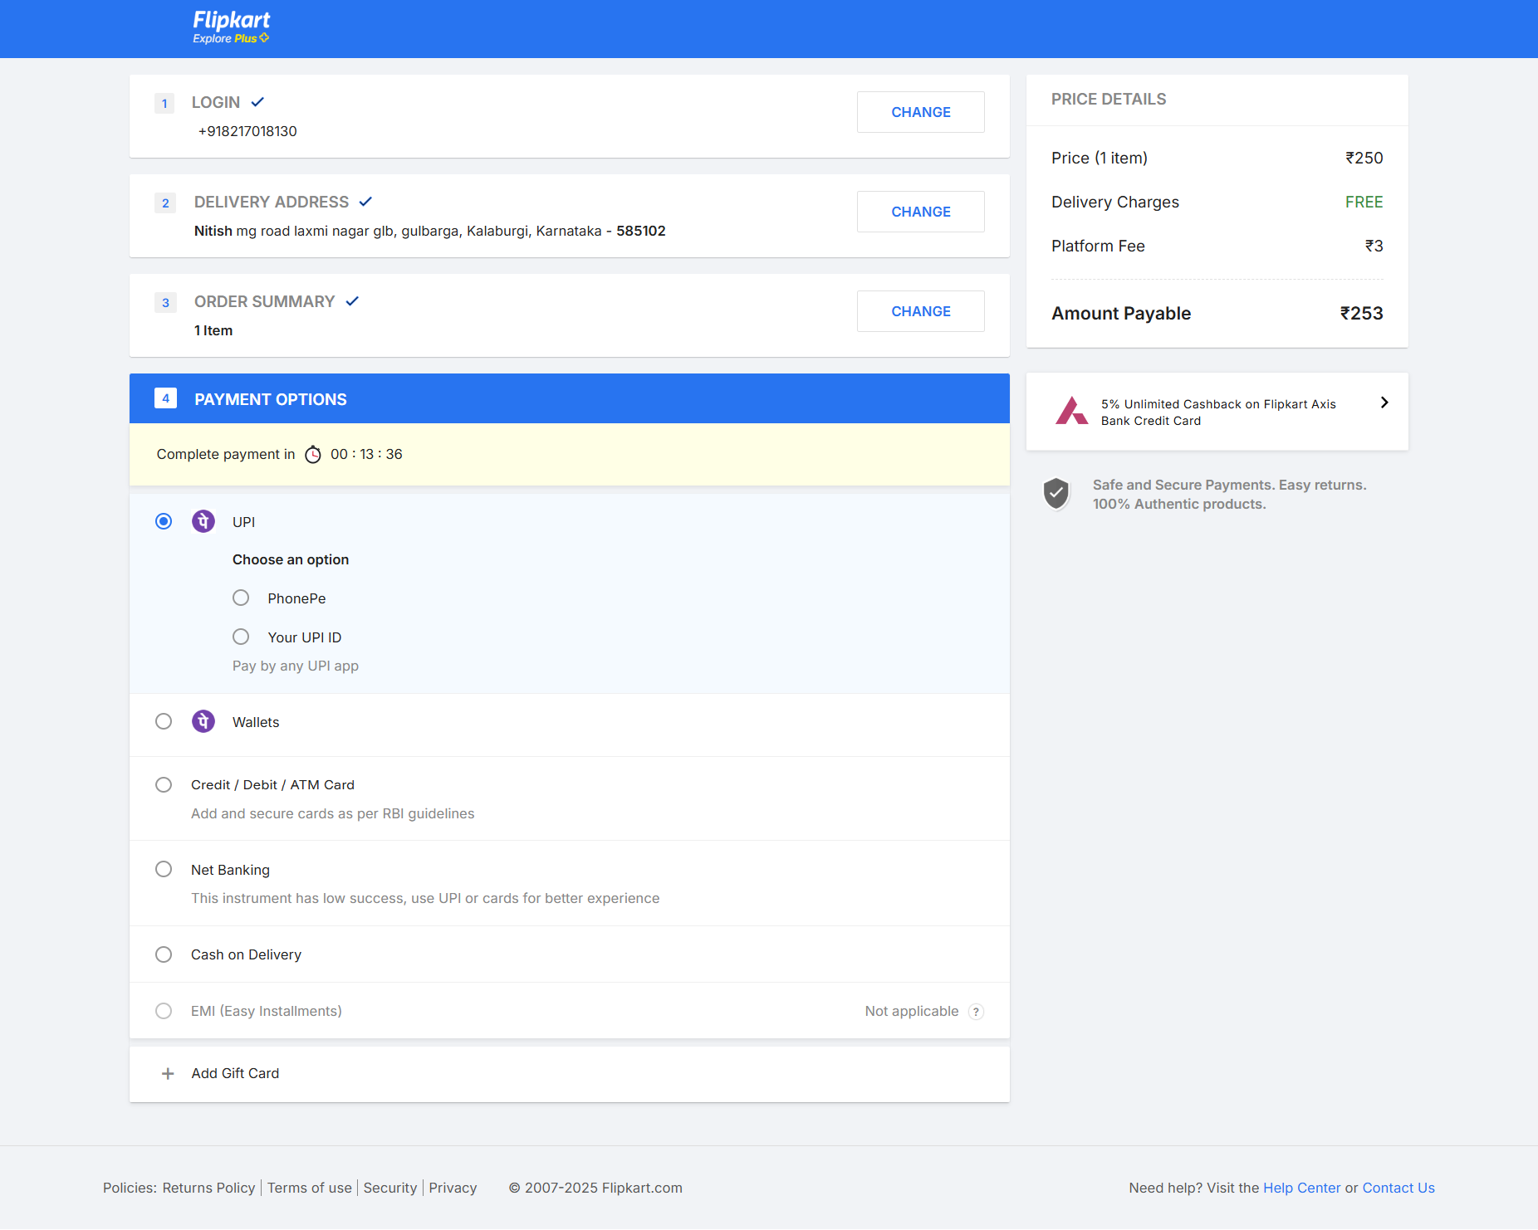

💯 Excellent! Now I'll break it down **STEP-BY-STEP** 🔥

👉 how Flipkart handles "Add to Cart"** in **two different ways:**

### ✅ **1. When User is NOT LOGGED IN (LocalStorage Method)**

### ✅ **2. When User is LOGGED IN (Database Method)**

---

## ✅ **STEP 1: When User is NOT LOGGED IN (LocalStorage Method)**

👉 In Flipkart, if the user is **NOT LOGGED IN**, they don't save the cart in the database.

👉 Instead, **they use LocalStorage (Browser Storage)** to temporarily hold the cart.

---

### 💻 **How Flipkart Handles Add to Cart Without Login**

### ✔ What Happens When You Click "Add to Cart"?

- When you click **Add to Cart**, it stores the product **in LocalStorage**.

- Then it **immediately redirects** you to the **Cart Page (`/cart`)**.

- On the cart page, it fetches the product from **LocalStorage** and displays it.

---

### ✅ **Step 1: Click "Add to Cart" Button (JS Code)**

👉 Here's how Flipkart does it without login.

### **HTML (Add to Cart Button)**

```html

<button onclick="addToCart('abc123', 'Printed T-shirt', 250, 'S')">

Add to Cart

</button>

```

---

### ✅ **JavaScript Function (Add to Cart Functionality)**

👉 **This function stores the product in LocalStorage.**

👉 It also redirects to `/cart`.

```js

function addToCart(tagId, productName, price, size) {

// ✅ Check if cart already exists in LocalStorage

let cart = JSON.parse(localStorage.getItem('cart')) || [];

// ✅ Push the new product to the cart array

cart.push({

tagId: tagId,

productName: productName,

price: price,

size: size,

quantity: 1

});

// ✅ Store updated cart in LocalStorage

localStorage.setItem('cart', JSON.stringify(cart));

// ✅ Redirect to Cart Page

window.location.href = '/cart.html';

}

```

---

### ✅ **Step 2: Render Cart Page (/cart) from LocalStorage**

👉 Now when you land on the **cart page**, it should automatically show the product.

👉 **Create `cart.html` and add this JS:**

### **cart.html (JavaScript)**

```js

document.addEventListener('DOMContentLoaded', () => {

// ✅ Get Cart Data from LocalStorage

const cart = JSON.parse(localStorage.getItem('cart')) || [];

// ✅ Select Cart Container

const cartContainer = document.querySelector('.cart-items');

// ✅ Loop through Cart Items and Render

cart.forEach(item => {

cartContainer.innerHTML += `

<div class="cart-item">

<h3>${item.productName}</h3>

<p>Price: ₹${item.price}</p>

<p>Size: ${item.size}</p>

<button onclick="removeFromCart('${item.tagId}')">Remove</button>

</div>

`;

});

});

// ✅ Remove from Cart Function

function removeFromCart(tagId) {

let cart = JSON.parse(localStorage.getItem('cart')) || [];

cart = cart.filter(item => item.tagId !== tagId);

localStorage.setItem('cart', JSON.stringify(cart));

window.location.reload();

}

```

---

### ✅ **Step 3: Now the Cart Works Without Login!** 🚀

👉 Now if the user:

- ✅ **Adds a product to cart** → It saves in **LocalStorage**.

- ✅ **Redirects to Cart Page** → It fetches data from LocalStorage and renders.

- ✅ **Removes from Cart** → Updates LocalStorage.

---

### ✅ **How It Looks Without Login**

| Action | What Happens |

|---------------|--------------------------------------------------------------------------|

| **Add to Cart** | Product saved in LocalStorage & redirected to Cart Page. |

| **Reload Page** | Product still shows from LocalStorage. |

| **Remove Product** | Product removed from LocalStorage & page reloads. |

| **Close Browser** | Cart data still exists (until cache is cleared). |

---

### ✅ **Why Flipkart Does This Without Login?**

👉 **They don't store data in Database** unless the user logs in.

👉 It saves **time** and avoids **database overload**.

👉 Once the user logs in, it **syncs LocalStorage data with the database**.

---

## ✅ **STEP 2: When User is LOGGED IN (Database Method)**

👉 Now comes the magic!

👉 When you log in to Flipkart, it stops using **LocalStorage**.

👉 Instead, it saves the product **in the Database (MongoDB)**.

---

### ✅ **What Happens in Flipkart When Logged In?**

| Action | What Happens |

|-------------------|-------------------------------------------------------------------------------|

| **Add to Cart** | Sends the Product to **Database** (`user.cart`). |

| **Redirect to Cart** | Cart Page fetches data from **Database**. |

| **Remove Item** | Removes the product from the Database. |

| **Logout** | Cart is still saved in the Database. |

---

### ✅ **Step 1: Add to Cart Button (Same as Before)**

👉 Same HTML Button:

```html

<button onclick="addToCart('abc123')">Add to Cart</button>

```

---

### ✅ **Step 2: JavaScript (Call Backend API)**

👉 Now when you click **Add to Cart**, it sends data to the backend.

### **JavaScript:**

```js

async function addToCart(productId) {

const response = await fetch('/add-to-cart', {

method: 'POST',

headers: {

'Content-Type': 'application/json',

},

body: JSON.stringify({

productId: productId

})

});

if (response.ok) {

window.location.href = '/cart';

}

}

```

---

### ✅ **Step 3: Node.js Backend API (Save to Cart in MongoDB)**

👉 This API saves the product in the Database.

### **Node.js (addToCart API)**

```js

const express = require('express');

const app = express();

const User = require('./models/User');

app.post('/add-to-cart', async (req, res) => {

const { productId } = req.body;

const userId = req.user._id;

// ✅ Push the product to the user's cart

await User.findByIdAndUpdate(userId, {

$push: { cart: { productId: productId } }

});

res.status(200).json({ message: 'Added to Cart' });

});

```

---

### ✅ **Step 4: Fetch Cart Items From Database**

👉 Now when the user goes to `/cart`, it fetches the cart items.

### **cart.js (Frontend)**

```js

document.addEventListener('DOMContentLoaded', async () => {

const response = await fetch('/get-cart');

const data = await response.json();

data.cart.forEach(item => {

document.querySelector('.cart-items').innerHTML += `

<div>

<h3>${item.productName}</h3>

<p>${item.price}</p>

<button>Remove</button>

</div>

`;

});

});

```

---

### ✅ **Step 5: Backend API (Fetch Cart)**

👉 This API fetches all cart items for the user.

### **Node.js (Get Cart API)**

```js

app.get('/get-cart', async (req, res) => {

const userId = req.user._id;

const user = await User.findById(userId).populate('cart.productId');

res.json({ cart: user.cart });

});

```

---

## ✅ **What Happens When User Logs In?**

| Action | What Happens |

|--------------------|----------------------------------------------------------------------------|

| ✅ Add to Cart | Product saved in MongoDB. |

| ✅ Redirect to Cart | Product fetched from MongoDB. |

| ✅ Remove Item | Product removed from MongoDB. |

| ✅ Logout | Cart still saved in MongoDB (persistent). |

---

## 💯 **Summary: How Flipkart Works**

| Scenario | Storage Method | Data Persistence |

|-----------------|--------------------|----------------------------------------|

| **Without Login** | LocalStorage | Lost after clearing browser cache. |

| **With Login** | MongoDB (Database) | Always saved in database. |

---

## 🚀 **👉 Should I Now Build This Entire Flow for You?**

💯 **I can now build:**

✅ **Add to Cart**

✅ **LocalStorage + MongoDB Sync**

✅ **Cart Page with + / - Quantity**

✅ **Place Order**

👉 **Should I go ahead and build it like Flipkart?** 🚀🔥